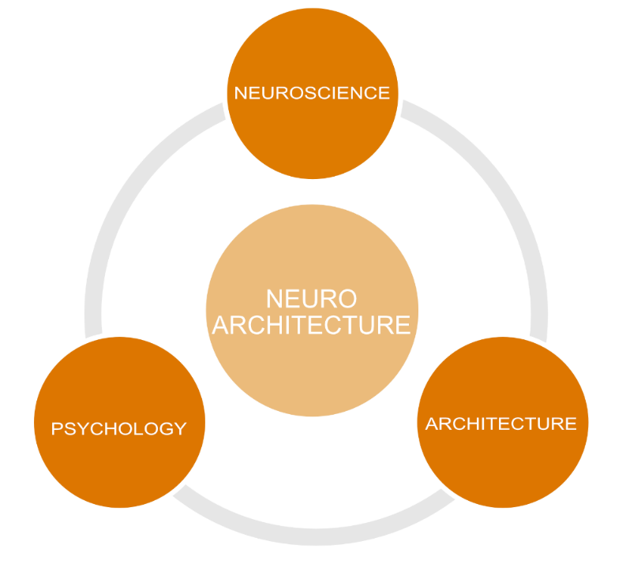

Dani Kolker 2021-2022: Neuroarchitecture: Enriching Pediatric Behavioral Health Environments

“Changes in the environment change the brain, and therefore they change our behavior.” - Fred Gage

“We shape our buildings; thereafter they shape us.” - Winston Churchill

Drawing inspiration from Fred Gage's claim that environmental changes alter the brain, thereby influencing behavior, and Winston Churchill's reflection on the relationship between humans and their built environments, this research project aims to better understand and advance the relationship between Neuroscience and Architecture. At the intersection of Neuroscience, Psychology, and Architecture, Neuroarchitecture offers vast opportunities for exploration by both Neuroscientists and Architects.
Recognizing the profound impact of spatial experiences on mental health, healing, productivity, and social interactions, it is imperative to design spaces that prioritize mental health and well-being. With the alarming statistic from the Center for Health Design highlighting that individuals with mental illnesses are 75 times more reactive to negative stimuli in the built environment, this study's interdisciplinary approach provides architects and designers with in-depth knowledge rooted in neuroscience. The goal is to foster design decisions that enrich pediatric behavioral health environments.

